FUZZY EXPERT SYSTEM FOR STOCK PORTFOLIO SELECTION:
AN APPLICATION TO BOMBAY STOCK EXCHANGE

ABSTRACT

Selection of proper stocks, before allocating investment ratios, is always a crucial task for investors. The presence of many influencing factors in stock performance has motivated researchers to adopt various Artificial Intelligence (AI) techniques to make this challenging task easier. In this paper, a novel data-driven fuzzy expert system model is proposed to evaluate and rank the stocks listed under the Bombay Stock Exchange (BSE). To eliminate human bias, a robust outlier control mechanism via Winsorization combined with panel-data Grey Relational Analysis (GRA) and an algorithmic feature selection framework are deployed to objectively identify high-impact, conditionally independent financial factors. Statistical fuzzification is introduced to define the boundaries of the trapezoidal membership functions objectively, utilizing historical percentile distributions rather than arbitrary expert ranges. Dempster-Shafer (DS) evidence theory is systematically applied to construct the fuzzy rule base, utilizing the statistical reality of historical performance data to automatically generate the rule consequents. Later, a portfolio optimization model is constructed, leveraging an Ant Colony Optimization (ACO) algorithm to maximize a modified Sharpe-type risk-to-reward ratio based on fuzzy portfolio returns and weighted mean semi-variance. Empirical evaluation demonstrates that this data-driven framework yields exceptional predictive accuracy, demonstrating enhanced scalability, robustness, and superior objective decision-making capabilities compared to traditional heuristic-based models.

Keywords: Stock Ranking; Portfolio Optimization; Grey Relational Analysis; Dempster-Shafer Theory; Fuzzy Expert System; Ant Colony Optimization.

1. Introduction
Stock portfolio selection is basically an optimal allocation of investors’ assets among a certain number of stocks to provide maximum return with minimum risk. There are different types of factors which directly or indirectly influence the performance of stocks. This has made the task of stock selection and portfolio construction very challenging and uncertain for stock market researchers since the very beginning. According to the work of Markowitz [1], portfolio selection may include two stages: firstly, performances of different securities are observed with beliefs about their future performances, and secondly, a proper choice of portfolio is made with relevant beliefs about future performances. The main aim in Modern Portfolio Theory (MPT) of investment is to maximize the expected return of the portfolio for a given amount of portfolio risk, or equivalently minimize risk for a given level of expected return, by carefully choosing the proportions of various assets. In the ground-breaking work, Markowitz [1] quantified return as the mean and risk as the variance of the portfolio of securities. The relationship between risk and mean-variance was later examined in various researches [2, 3, 4, 5]. The twin objectives of investors—profit maximization and risk minimization—are thus quantified.
The portfolio selection problem has proven to be a multi-dimensional problem, and to solve the inherent multi-criteria nature of this problem, Multi-criteria Decision Making (MCDM) approaches have been adopted in various researches [6, 7, 8, 9]. In spite of all these efforts, researchers faced difficulties in bringing efficiency to portfolios, especially in dynamic, uncertain environments. As a result, the use of different Artificial Intelligence (AI) techniques in stock selection and portfolio construction became inevitable due to their well-known capability of handling uncertain and vague data. In the literature, we can find wide use of different AI and Soft Computing techniques to analyze and predict the performance of stocks in various stock exchanges around the world. In some researches [10, 11, 12, 13, 14], the efficient learning capability of Artificial Neural Networks (ANN) is adopted to select stocks and construct portfolios, whereas in other researches [15, 16, 17, 18, 19], the optimization capability of Genetic Algorithms (GA) is used for portfolio optimization. However, the application of Fuzzy Logic and Fuzzy Set theory has become the most popular among other soft computing techniques, due to its uncertainty handling capability and its efficiency in incorporating vagueness in investors’ preferences during portfolio construction [20, 21, 22, 23, 24].
The portfolio selection process can be divided into two stages [25]. In the first stage, some stocks are selected to construct the portfolio, and in the second stage, the percentage of the total value for each stock is identified. The use of fuzzy expert systems in the selection of stocks and equity has recently become very effective and popular. In a work, Fasanghari et al. [22] developed a fuzzy expert system to select superior stocks in the Tehran Stock Exchange (TSE) by identifying 7 factors influencing the stock market. A rule base of totally 932 rules was constructed for this purpose. Though no proper portfolio optimization model was used in this work, the outcome of the model proved to be satisfactory. But the major concern of this model, and similar heuristic-based models, is the development time, cost, and epistemological bias introduced by repetitive human expert interactions for the development of the rule base. Furthermore, the authors used only fuzzy set theory to deal with the inherent uncertainty present in the rule base, though fuzzy set theory is more effective in dealing with vagueness in the model than addressing the non-probabilistic inherent uncertainty of market performance [26]. In another significant work, Xidonas et al. [25] developed an expert system for the selection of equity securities, but the concerns remained more or less the same as the previous one.
In this research, the selection of stocks is made with the help of a data-driven expert system where the fuzzy rule base is automatically generated by systematically applying Dempster-Shafer (DS) evidence theory to historical statistical realities.
- This methodology minimizes the overall development time and cost while eliminating human bias, as the required number of subjective expert interactions is completely replaced by empirical rigor.
- DS evidence theory is well known for its capability of dealing with incomplete and uncertain information. Thus, another level of uncertainty handling mechanism beside fuzzy set theory is incorporated into the model.
The proposed model is implemented in two phases.
(1) Initially, financial ratios are evaluated using a robust algorithmic feature selection framework. Instead of subjective expert consensus, an objective outlier control mechanism via Winsorization is applied, followed by panel-data Grey Relational Analysis (GRA) to identify critical high-impact factors. After applying a correlation filter to ensure conditional independence, four factors—Earnings Per Share, Price to Book Value, Profit Margin, and Debt-to-Equity Ratio—are finally selected. Their historical data for the implementation period of FY 2013-14 to FY 2020-21 are collected. These four factors function as the inputs of the proposed DS fuzzy expert system. To eliminate arbitrary expert ranges, statistical fuzzification utilizing historical percentile distributions is introduced to objectively define membership boundaries. The historical data is then used to systematically generate the consequents of the fuzzy rules via DS evidence theory using a weighted probability assignment. The model is tested with longitudinal data from the testing years (FY 2021-22 to FY 2024-25), where the variables are provided as input to the fuzzy inference engine, and the stocks are ranked based on their defuzzified output.
(2) A portfolio optimization model is constructed and then solved utilizing an Ant Colony Optimization (ACO) algorithm. This optimization maximizes a modified Sharpe-type risk-to-reward ratio based on fuzzy portfolio returns and weighted mean semi-variance, dynamically allocating investment capital by giving preference to the top-ranked stocks.
The model is tested with the data of FY 2021-22 to predict the performance of different stocks in FY 2022-23, FY 2023-24 and FY 2024-25. Performance of the model is proved to be satisfactory when compared with the actual performance of stocks. Figure 1 depicts the brief structure of the article.
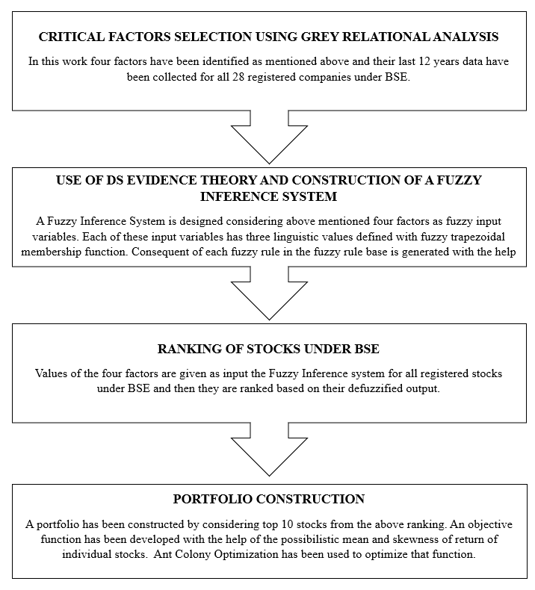
Fig. 1. Design diagram of the proposed model
The rest of the paper is organized as follows: Section 2 outlines the algorithmic feature selection process, discussing the use of Winsorization and Grey Relational Analysis to objectively identify critical financial factors. Section 3 elaborates on the design of the proposed data-driven DS fuzzy expert system, including statistical fuzzification and evidence-based rule generation. Portfolio construction using the ACO algorithm is discussed in Section 4. Result analysis and comparison with the recent performance of stocks are detailed in Section 5, and finally, Section 6 concludes the discussion.

2. Identification of Critical Factors
According to value investors, there is no strictly singular approach to analyzing stocks due to the inherent presence of multi-dimensional market uncertainties. Financial analysts evaluating equities under the Bombay Stock Exchange (BSE) typically monitor a broad spectrum of fundamental indicators. Through an extensive literature survey and foundational financial theory, an initial comprehensive set of critical financial metrics was identified for evaluation. These included the price-to-earnings ratio (P/E), dividend payout ratio (PR), diluted earnings per share (EPS), price-to-book value (P/B), price-to-sales ratio (P/S), debt-to-equity ratio (D/E), current ratio (CR), and profit margin (PM).
However, to minimize the computational complexity of the proposed expert system and to satisfy the strict conditional independence requirements of the subsequent Dempster-Shafer rule engine, the number of input factors needed to be systematically reduced. Historically, researchers have relied on the tacit knowledge of domain experts through questionnaire surveys to shortlist these metrics. This subjective approach, however, introduces epistemological bias and relies on static assumptions that may not reflect the statistical reality of the market.
To overcome this bottleneck, this research deploys a purely objective, data-driven feature selection framework. Instead of human consensus, a 12-year historical panel dataset of the Sensex 30 companies is utilized to mathematically extract the most influential variables. To ensure the integrity of the selection process, a robust outlier control mechanism via Winsorization is first applied to the financial data. Subsequently, Grey Relational Analysis (GRA) is implemented to evaluate the panel data. By classifying the ratios into functional categories and calculating their Grey Relational Grade (GRG) against annual return, the system objectively ranks the fundamental factors based on their true empirical impact on stock performance. The step-by-step implementation of this algorithmic factor identification is discussed below.
2.1. Algorithmic Feature Selection via Grey Relational Analysis
Originating from Grey System Theory proposed by Deng in 1982, GRA is highly effective at analyzing systems with incomplete or "grey" information, making it mathematically ideal for volatile financial markets. Instead of relying on expert questionnaires to determine which financial ratios are important, GRA measures the absolute geometric similarity between a reference sequence (the actual historical performance of the stocks) and comparability sequences (the fundamental financial ratios).
For the objective selection of critical factors, a 12-year panel dataset (FY 2014 to FY 2025) of the Sensex 30 companies was utilized. The automated feature selection process is implemented through the following steps:
2.1.1. Data Preparation and Outlier Control (Winsorization)
Financial datasets are heavily prone to extreme outliers (e.g., anomalous negative earnings or massive debt spikes in banking sectors), which can severely distort distance-based mathematical models like GRA. Before processing, a Winsorization technique is applied to clamp extreme values. The 5th and 95th percentiles of each ratio's historical distribution are calculated to establish the dynamic lower and upper boundaries. Any data point falling outside this range is mathematically capped to the boundary limit.
2.1.2. Grey Data Normalization
Because the evaluated financial ratios possess different dimensions, scales, and functional relationships with stock performance, the Winsorized data must be normalized into a uniform scale of 0 to 1.
In this framework, the actual Annual Return of the stocks is designated as the Reference Sequence X0. The selected financial ratios act as the Comparability Sequences Xi.
The financial ratios are categorized based on their theoretical relationship with the Annual Return:
- Type A (Benefit/Larger-is-Better): For ratios where higher values are historically favorable for investors (e.g., Diluted EPS, Profit Margin, Dividend Payout Ratio), the data is normalized using:
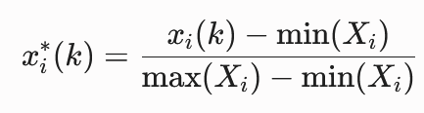
- Type B (Cost/Smaller-is-Better): For ratios where lower values generally indicate lower risk or better value (e.g., Debt-to-Equity, Price-to-Earnings, Price-to-Book), the data is normalized using:
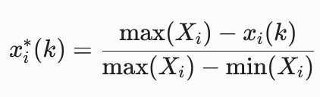
(Note: In the context of this study, min(Xi) and max(Xi) represent the respective 5th and 95th Winsorized boundaries.)
2.1.3. Grey Relational Coefficient (GRC) Calculation
Once normalized, the Grey Relational Coefficient ξi(k) is calculated to determine the proximity of the i-th financial ratio sequence to the Annual Return reference sequence at the k-th instance. It is computed as follows:
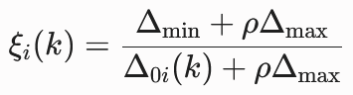
Where:
- 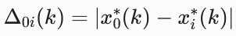 is the absolute difference between the reference sequence and the comparability sequence.
- Δmin and Δmax are the global minimum and maximum absolute differences across all sequences in the panel data.
- ρ is the distinguishing coefficient. Consistent with standard Grey System methodology to ensure stability and provide moderate distinguishing effects, ρ is set to 0.5.
2.1.4. Grey Relational Grade (GRG) and Objective Ranking
The individual coefficients are then aggregated into a single scalar value known as the Grey Relational Grade (GRG), denoted by γi. The GRG represents the overall level of influence that a specific financial ratio has on the Annual Return over the entire 12-year dataset.
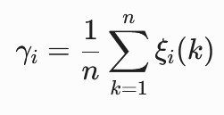
The fundamental factors are then strictly ranked by their γi values as shown in Table 1. The highest-scoring variables mathematically represent the most reliable historical predictors of stock returns. Table 1: Ranking Of Most Important Factors Based on GRG
Factor | Grey Relational Grade | Rank
Diluted EPS | 0.765640224 | 1
Payout ratio | 0.7307598875 | 2
Profit margin | 0.636568517 | 3
Debt to equity | 0.5797097518 | 4
Price to sales | 0.5554044484 | 5
Price to BV | 0.4631327501 | 6
Price to Earning | 0.4629761609 | 7
Current ratio | 0.4521822864 | 8

In Figure 2, the trajectory mapping shows how the high-ranked ratios, like Diluted EPS, geometrically shadow the target Annual Return curve more closely than lower ranked ratios.

Figure 2: Trajectory mapping Of Factors w.r.t Reference Sequence (Annual Return)
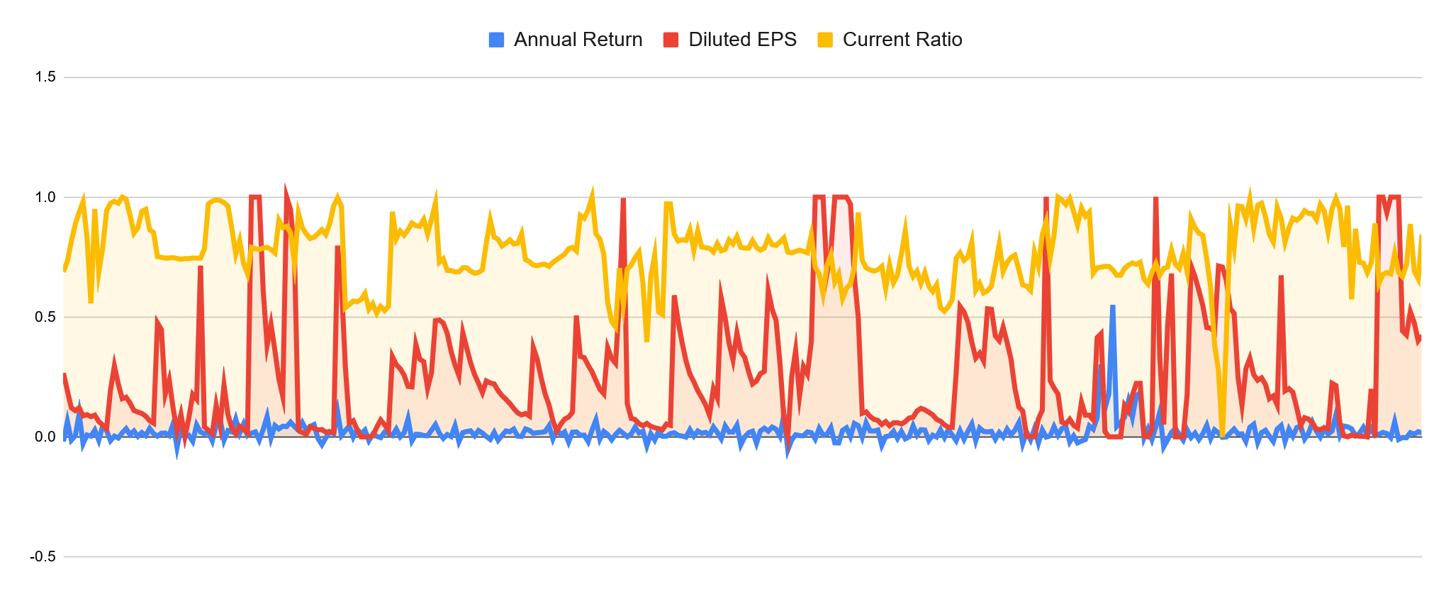

2.2. Selection of Input Factors for the Proposed Model
In this research, a fuzzy expert system is used for the selection and ranking of stocks. The consequents of the fuzzy rules in the knowledge base are automatically generated by applying Dempster-Shafer (DS) evidence theory, where historical data of the selected financial factors serve as independent bodies of evidence regarding stock performance. However, a major mathematical constraint of the DS combination rule is the strict requirement for conditional independence among the evidence. If highly correlated inputs are used simultaneously, the DS engine will "double-count" the evidence, leading to an artificially biased result (over-confidence or super-estimates).
To systematically ensure conditional independence, the top-ranked ratios derived from the Grey Relational Analysis (GRA) are evaluated for systemic redundancies using a temporal-combinatorial optimization approach.
2.2.1. Calculation of Risk-Adjusted Impact Scores
Before checking for dependencies, the raw financial ratios must be normalized against the structural quality of the stock's performance. The Semivariance-to-Return ratio (S/R) is utilized as a robust indicator of Risk-Adjusted Efficiency.
First, the historical Mean Return (R) and Semivariance (S) are calculated for each company using the 12-year price data. Semivariance isolates downside risk by measuring only the negative deviations from the mean. For n periods and annual return rk, the formula is:
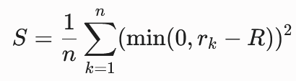
The raw value of any financial factor is then divided by the S/R value of that particular stock to determine its "predictive power per unit of risk". This result is termed the impact score:
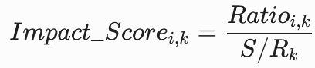
Using S/R as the divisor ensures that a high valuation multiple in a low-risk, high-return stock yields a high impact score, whereas the same multiple in a high-risk stock yields a lower score. To ensure statistical power and observe consistent relationships, data from the last three financial years (2023, 2024, and 2025) are stacked, generating 90 distinct stock-year observations for each fundamental ratio.
2.2.2. Mathematical Optimization Framework for Feature Selection
A correlation matrix is generated using the 90 stacked impact score observations. To programmatically identify the optimal four-variable sub-matrix from the pool of 70 unique permutations (derived from the top 8 GRA ratios), a Multi-Objective Vector Optimization engine was formulated.Table 2 shows these correlation coefficient values for FY 2022-23 .The level of dependencies of factors are shown in Figure 3, 4 and 5 for the three financial years
Table 2: Correlation coefficient values for FY 2022-23
FACTORS | EPS | Payout | PM | P/B | P/E | P/S | CR | D/E
EPS | 1.00 | 0.31 | 0.23 | 0.31 | 0.42 | 0.40 | 0.42 | -0.06
Payout | 0.31 | 1.00 | 0.66 | 0.69 | 0.53 | 0.81 | 0.79 | -0.03
PM | 0.23 | 0.66 | 1.00 | 0.32 | 0.28 | 0.70 | 0.61 | 0.38
P/B | 0.31 | 0.69 | 0.32 | 1.00 | 0.82 | 0.80 | 0.81 | -0.10
P/E | 0.42 | 0.53 | 0.28 | 0.82 | 1.00 | 0.73 | 0.66 | 0.01
P/S | 0.40 | 0.81 | 0.70 | 0.80 | 0.73 | 1.00 | 0.81 | 0.15
CR | 0.42 | 0.79 | 0.61 | 0.81 | 0.66 | 0.81 | 1.00 | -0.08
D/E | -0.06 | -0.03 | 0.38 | -0.10 | 0.01 | 0.15 | -0.08 | 1.00

Fig. 3. Dependencies of factors in FY 2022-23
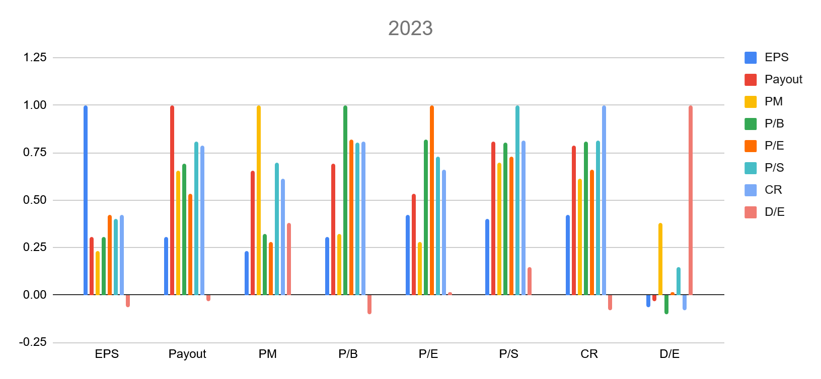
Fig. 4. Dependencies of factors in FY 2023-24
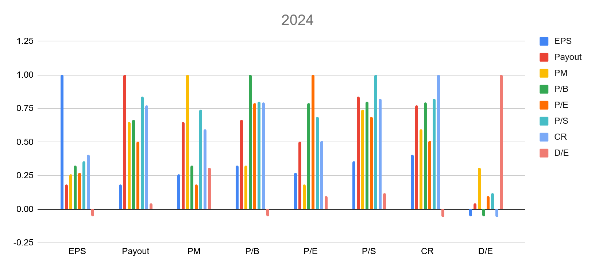
Fig. 5. Dependencies of factors in FY 2024-25
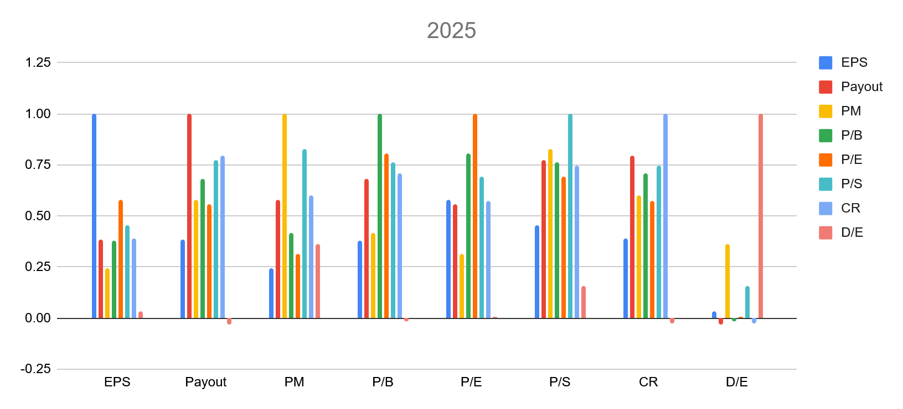

Step 1: Information Preserving Time-Aggregation Because positive and negative correlation signs can cause values to cancel out across a multi-year time series, an Average Absolute Correlation Matrix (R_abs) was mapped to accurately preserve total systemic dependency:
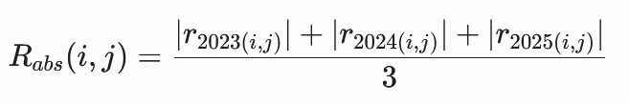
Step 2: Dual-Objective Function Scalarization Let S be a subset of chosen indexes where the size equals 4. The optimization space balances two conflicting target paths, normalized via standard Min-Max mapping:
- Maximize Informational Quality: f1(S) = Σ GRA_Score(i) for all elements in S.
- Minimize Redundancy Noise: f2(S) = Mean(R_abs(i, j)) for all 6 unique internal pairs in S.
- Global Utility Function: Maximize U(S) = 0.5 * f1*(S) - 0.5 * f2*(S).
Step 3: MiniMax Peak Correlation Guardrail To protect the fusion algorithm from being corrupted by a single extreme collinear pair hidden behind a low overall average, a strict threshold limit was applied.
Subject to: max |r_year(i, j)| < 0.70 for all pairs in S across all three individual years.
2.2.3. Final Strategic Selection
Based on the formal integration framework, the finalized independent factors chosen for the proposed expert system are: Diluted Earnings per Share (EPS), Profit Margin (PM), Price-to-Book (P/B), and Debt-to-Equity (D/E).
This specific architectural configuration provides crucial structural advantages that directly safeguard the mathematical requirements of the Dempster-Shafer combination rule:
- Strict Adherence to Evidence Independence: The absolute peak pairwise link inside this configuration is exceptionally low at 0.4162 (occurring between Profit Margin and Price-to-Book in 2025). This prevents artificial over-confidence during evidence aggregation.
- Multidimensional Metric Coverage: It ensures a holistic, 360-degree evaluation of corporate health by covering four completely distinct economic layers: Earning Power (EPS), Operational Efficiency (PM), Market Pricing Anchor (P/B), and Leverage Risk (D/E).
- Elimination of Valuation Loops: By explicitly excluding highly correlated pairs like Price-to-Earnings and Price-to-Sales, the framework successfully eliminates internal valuation loops that would otherwise compound market sentiment errors and destabilize the basic belief assignments.
Diluted Earnings per Share (EPS):
Diluted EPS is a conservative profitability metric that calculates the portion of a company’s net income allocated to each share of common stock, assuming that all convertible securities (such as stock options, convertible bonds, and warrants) are exercised. It serves as a rigorous indicator of a company’s fundamental earning power.

Profit Margin (PM):
Profit Margin is a core operational efficiency ratio that measures the percentage of revenue a company retains as net income after all expenses, taxes, and interest are paid. It indicates how effectively a company’s management controls its operational costs and converts top-line sales into actual bottom-line profit.
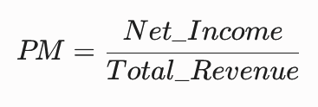
Price-to-Book Ratio (P/B):
The Price-to-Book ratio is a critical market valuation anchor that evaluates the market's pricing of a company relative to its actual net asset value (book value). It is used by value investors to determine whether a stock is overvalued or undervalued compared to the accounting value of its equity.
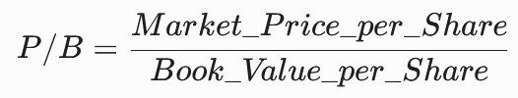

Debt-to-Equity Ratio (D/E):
The Debt-to-Equity ratio is a structural leverage metric that measures the degree to which a company's assets and operations are financed by debt versus wholly-owned shareholder funds. It acts as an orthogonal risk vector in the system, reflecting the long-term structural solvency and capital risk profile of the firm.
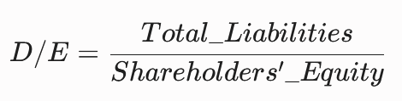

- Evaluation and Ranking of Stocks using the Proposed Model
Dempster-Shafer (DS) evidence theory and a fuzzy rule-based expert system are hybridized in this work to evaluate and rank the stocks listed under the BSE. A brief introduction to DS evidence theory and fuzzy rule-based expert systems is provided here before elaborating on their specific application within the proposed model.
3.1. Dempster-Shafer (DS) Evidence Theory
A. P. Dempster in 1967 proposed a multi-valued mapping from one space to another, which was used for statistical inference when identifying a single hypothesis from multiple pieces of sample information. The DS-theory was formally proposed by Dempster in 1968 and later extended by Shafer in 1976 to systematically deal with incomplete and uncertain information.
DS-Theory mainly revolves around four core components: the frame of discernment, Basic Probability Assignment (BPA), plausibility function (Pl), and belief function (Bel).
In evidence theory, a set of hypotheses Θ, called the frame of discernment, is first assumed and defined as follows:
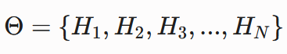
The set is composed of N mutually exhaustive and exclusive hypotheses. From Θ, let P(Θ) denote the power set composed of 2^N propositions of Θ:
where ∅ denotes the empty set.
The most critical task in applying evidence theory is establishing the Basic Probability Assignment (BPA). A BPA is a function from P(Θ) to [0, 1] defined by:
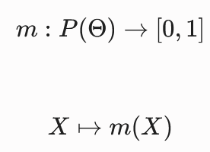
which strictly satisfies the following mathematical criteria:
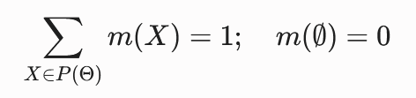
Dempster’s rule of combination, denoted by m = m1 ⊕ m2, can orthogonally combine two independent BPAs (m1 and m2) to yield a new BPA:
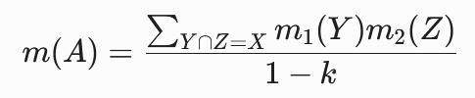
(where the sum is over all Y ∩ Z = A)
with the conflict normalization constant k defined as:
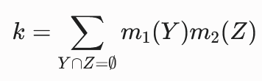
Here, k measures the degree of conflict between m1 and m2. A value of k = 0 corresponds to a complete absence of conflict, whereas k = 1 implies total contradiction between the sources.
The resulting belief function derived from the combination of I independent information sources can be defined sequentially as:
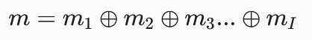
Through this orthogonal sum, multi-source information can be fused into a single framework very effectively. This capability proves highly advantageous when systematically applied to the fuzzy rule generation mechanism discussed later in this paper.
3.2. Fuzzy Expert System
For many real-world problems—such as strategic planning, medical diagnosis, and volatile financial decision-making—solutions require more than simple Boolean reasoning and demand expert domain knowledge. Expert Systems (ES) have become critical tools because they are capable of representing and reasoning within knowledge-rich domains to solve complex problems. The primary advantage of an ES over conventional software is its deductive reasoning capability, processing knowledge rather than raw data.
Concurrently, fuzzy set theory has emerged as a premier mathematical framework for handling vagueness and uncertainty, seeing wide application in system modeling, optimization, and supervision. By integrating these paradigms, a fuzzy expert system is utilized to construct the proposed ranking model.
A fuzzy expert system utilizes fuzzy logic instead of strict Boolean logic within its knowledge base, deriving conclusions from continuous user inputs and a fuzzy inference process. Figure 6 depicts the basic architecture of a fuzzy expert system.
Fig. 6. Architecture of Fuzzy Rule-based Expert System
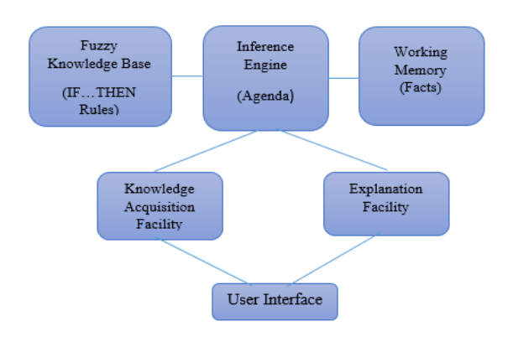
The basic architecture of a fuzzy expert system comprises several integrated modules:
- Fuzzy Knowledge Base: This is a collection of fuzzy rules typically structured by a knowledge engineer. The fundamental syntax of a fuzzy rule is:
where I1, I2, ..., In are fuzzy linguistic input variables and i1, i2, ..., in are possible linguistic values. Similarly, O is the fuzzy linguistic output variable and o is its linguistic value. The premise terms represent fuzzy propositions suggesting partial set membership, allowing the model to evaluate degrees of truth rather than absolute states.
- Fuzzy Inference Engine: To process the rules within the knowledge base, an inference mechanism is adopted to deduce a logical conclusion. Various aggregation, implication, and operator methods (s-norms and t-norms) govern this engine. This module also executes the defuzzification process, translating the fuzzy output back into a crisp, actionable scalar value based on an agenda of prioritized rules triggered by facts in the working memory.
- Working Memory: This module contains the global database of current facts and instantiated data points utilized by the fuzzy rule base during the inference cycle.
- Explanation Facility: This module tracks and explains the sequential reasoning steps the ES took to arrive at a specific conclusion.
- Knowledge Acquisition Facility: This provides a mechanism for entering and updating knowledge within the system structure.
- User Interface: This module facilitates all interactions between the user and the system, accepting initial crisp inputs and displaying the defuzzified outcomes of the inference process.

3.3. Implementation of the Proposed Model
The structural framework of the proposed model was introduced in Section 1 (Figure 1). Here, the specific sequential steps followed to construct, normalize, and implement the data-driven framework are elaborated.

3.3.1. Collection and Normalization of Historical Data
A total of 28 active stocks under the Sensex 30, registered under the BSE, were taken. Initially, historical financial data for a 12-year longitudinal period (FY 2014 to FY 2025) covering the four conditionally independent factors extracted from the GRA optimization—Diluted Earnings per Share (EPS), Price to Book Value Ratio (P/B), Profit Margin (PM), and Debt-to-Equity (D/E)—were collected from reliable data vendors and exchange portals such as www.bseindia.com, www.nseindia.com and www.moneycontrol.com. The first 9 years of data (FY 2014 to FY 2022) are utilized for the training and implementation of the rule base, while the most recent 3 years of data (FY 2023 to FY 2025) are reserved strictly for out-of-sample testing and performance validation.
Because financial ratios possess inherently different scales and dimensions (e.g., EPS operates on an absolute currency scale, while Profit Margin is a percentage), the raw data must be normalized for the simplicity and stability of the expert system. The data is systematically normalized within a standardized range of [0, 10]. This is achieved by utilizing the Winsorized boundaries established during the feature selection phase: the historical 95th percentile value of any factor over the 9-year training period is scaled to 10, and all other data points are scaled relative to these bounds.Table 3 shows an example of actual and normalized data for Bajaj Finance Ltd.

Table 3. Sample normalized data for Bajaj Finance Ltd.
Financial Year | Actual EPS of Bajaj Finance Ltd | Transferred Data
2013-14 | 143.65 | 7.66
2014-15 | 177.7 | 9.48
2015-16 | 187.439 | 10
2016-17 | 33.67 | 1.8
2017-18 | 47.05 | 2.51
2018-19 | 68.75 | 3.67
2019-20 | 89.07 | 4.75
2020-21 | 73 | 3.89
2021-22 | 115.79 | 6.18

3.3.2. Fuzzification
Fuzzification is the process of taking a crisp numerical value as an input and transforming it into a degree of membership within specific linguistic terms. Uncertainty in financial markets fundamentally arises from imprecision, vagueness, or ambiguity, and one of the most effective mathematical ways to represent these non-probabilistic uncertainties is through fuzzy variables.
Fuzzy membership functions define these fuzzy variables. Instead of relying on arbitrary human assumptions, the model introduces statistical fuzzification, where historical percentile distributions objectively define the geometric boundaries. All four selected fundamental factors have been categorized using fuzzy linguistic variables, and each factor is partitioned into three distinct linguistic terms: Low, Standard, and High.
A trapezoidal membership function has been utilized to represent these inputs across the normalized universe of discourse [0, 10]. The specific geometric parameters defining the "Low", "Standard", and "High" trapezoidal boundaries for each of the four variables are detailed in Table 4.

Table 4. Membership functions for the linguistic values of the Input Variables
Factors in terms of linguistic variables | Linguistic Values | Fuzzy Trapezoidal Membership
Diluted EPS | Low | (0,0,0.55, 1.03)
 | Standard | (0.55, 1.03, 2.12, 4.01)
 | High | (2.12, 4.01,10,10)
Price to Book Value | Low | (0,0,1.01, 1.59)
 | Standard | (1.01, 1.59, 2.31, 3.55)
 | High | (2.31, 3.55,10,10)
Profit Margin | Low | (0,0,1.83, 3.37)
 | Standard | (1.83, 3.37, 4.90, 6.82)
 | High | (4.90, 6.82,10,10)
Debt to Equity | Low | (0,0,0.82, 1.74)
 | Standard | (0.82, 1.740, 3.16, 5.75)
 | High | ( 3.16, 5.75,10,10)

3.3.3. Fuzzy Rule Construction using DS-Theory
The most significant novelty of this research is the application of Dempster-Shafer (DS) evidence theory in the automated construction of the fuzzy rule base. The knowledge base of a fuzzy inference system consists of rules that determine how an output will be generated based on given inputs. The proposed system utilizes the four mathematically independent inputs selected in the previous phase: Diluted EPS, Price to Book Value Ratio (P/B), Profit Margin (PM), and Debt-to-Equity (D/E). Based on these parameters, the DS-Fuzzy system determines whether a stock is categorized as Highly Favourable, Moderately Favourable, or Not Favourable.
The frame of discernment (Θ) for stock performance is defined as:
Θ = {High_Performance, Average_Performance, Poor_Performance}
Data-Driven Derivation of Basic Probability Assignments (BPAs)
Historically, BPAs in fuzzy expert systems have been assigned using the subjective tacit knowledge of domain experts. To completely eliminate human epistemological bias, this framework derives its BPAs strictly from the statistical reality of the 9-year training dataset (FY 2014 to FY 2022).
The Semivariance-to-Return (S/R) ratio is utilized as the historical measure of risk-adjusted performance. Because a lower S/R value indicates superior historical performance per unit of downside risk, the ground truth performance of each stock-year observation is objectively labelled using percentile distributions:
- High Performance (HP): Observations falling below the 33.3rd percentile of the historical S/R distribution.
- Average Performance (AP): Observations falling between the 33.3rd and 66.6th percentiles.
- Poor Performance (PP): Observations falling above the 66.6th percentile of the S/R distribution.
Because the input data has been converted into fuzzy sets via trapezoidal membership functions, partial memberships exist (e.g., a stock might have a 0.6 membership in "High EPS" and a 0.4 membership in "Standard EPS"). To accurately capture this continuous reality without losing data in the overlapping regions, a Weighted Frequency Method is implemented.
In this method, the fuzzy membership grade (μ ∈ [0, 1]) acts as a mathematical weight of evidence. A stock with a membership of 0.5 in a specific category counts as half a piece of evidence, whereas a membership of 1.0 acts as a full piece of evidence. The exact mass function (m) for a specific linguistic state (e.g., "High EPS") pointing toward a specific performance hypothesis (e.g., HP) is calculated as follows:
This calculation is systematically executed across all states for all four financial factors. As a mandatory validation rule of Dempster-Shafer theory, the assigned masses for any given linguistic state must satisfy:
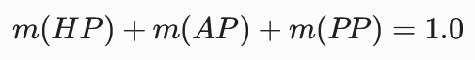
By applying this weighted frequency formula across the historical dataset, the system objectively learns the true predictive probabilities of each financial vector. The complete, mathematically derived Basic Probability Assignments for all linguistic states of the four factors are detailed in Table 5.

Table 5. Basic Probability Assignment
Factor | Linguistic Value | m(High_Performance) | m(Average_Performance) | m(Poor_Performance)
EPS | Low | 0.41 | 0.32 | 0.27
 | Standard | 0.34 | 0.32 | 0.34
 | High | 0.29 | 0.37 | 0.34
P/B | Low | 0.49 | 0.30 | 0.21
 | Standard | 0.32 | 0.37 | 0.32
 | High | 0.23 | 0.32 | 0.45
PM | Low | 0.42 | 0.33 | 0.25
 | Standard | 0.32 | 0.33 | 0.35
 | High | 0.32 | 0.35 | 0.34
D/E | Low | 0.33 | 0.36 | 0.30
 | Standard | 0.41 | 0.32 | 0.27
 | High | 0.28 | 0.32 | 0.39

To elaborate further on the exact mathematical synthesis of evidence, let us consider a specific sample rule from the generated knowledge base: Rule 1.
The premise of Rule 1 evaluates a scenario where all four conditionally independent financial ratios exhibit "Low" linguistic values. The respective Basic Probability Assignments (BPAs) for this specific state are drawn directly from the historical statistical matrix (derived from the 9-year training set):
Evidence 1 (m1): IF Diluted EPS is Low m1(HP) = 0.41, m1(AP) = 0.32, m1(PP) = 0.27
Evidence 2 (m2): IF Price-to-Book (P/B) is Low m2(HP) = 0.49, m2(AP) = 0.30, m2(PP) = 0.21
Evidence 3 (m3): IF Profit Margin (PM) is Low m3(HP) 0.42, m3(AP) = 0.33, m3(PP) = 0.25
Evidence 4 (m4): IF Debt-to-Equity (D/E) is Low (m4(HP) = 0.33, m4(AP) = 0.36, m4(PP) = 0.30
Because the frame of discernment Θ = {HP, AP, PP} consists of mutually exclusive and collectively exhaustive hypotheses, the standard Dempster’s rule of combination simplifies into a direct multiplicative orthogonal sum. Instead of calculating sequential pairwise matrices, all four independent pieces of evidence are fused simultaneously through the following steps:
- Step 1: Calculate Raw Unnormalized Beliefs (Numerators)
The raw belief for each hypothesis is calculated as the product of the individual masses pointing to that specific outcome:
Num_HP = m1(HP) * m2(HP) * m3(HP) * m4(HP) = 0.41*0.49*0.42*0.33 =0.02784474
Num_AP = m1(AP) * m2(AP) * m3(AP) * m4(AP) = 0.32*0.30*0.33*0.36 =0.0114048
Num_PP = m1(PP) * m2(PP) * m3(PP) * m4(PP) = 0.27*0.21*0.25*0.30 =0.0042525
- Step 2: Calculate the Conflict Normalization Factor (K)
Because multi-dimensional financial ratios will inevitably yield conflicting signals (e.g., a low P/B might indicate value, but a low Profit Margin indicates operational distress), the raw beliefs must be normalized to ensure they sum to 1.0. The normalization factor K represents the total non-conflicting mass:
K = Num_HP + Num_AP + Num_PP = 0.04350204
- Step 3: Calculate Final Combined Mass (mf)
The final, combined probability for each hypothesis is derived by dividing its raw numerator by K:
mf(HP) = Num_HP / K = 0.64
mf(AP) = Num_AP / K =0.055
mf(PP) = Num_PP / K =0.098
For Rule 1, applying this exact combinatorial methodology across the historical data yields a final combined mass value for High Performance (mf(HP)) of 0.64.
Because the final mass value for High Performance dictates the ultimate desirability of the stock for portfolio inclusion, the consequent linguistic outputs of the fuzzy rules are strictly mapped to the following mf(HP) thresholds:
Highly Favourable: mf(HP) ≥ 0.76
Moderately Favourable: 0.46 ≤ mf(HP) ≤ 0.75
Not Favourable: mf(HP) ≤ 0.45
Because the combined belief for High Performance (0.64) falls within the intermediate threshold, the mathematically derived consequent for this permutation is designated as Moderately Favourable.
Thus, the finalized, data-driven semantic rule is automatically formed as:
“IF Diluted EPS is Low AND Price-to-Book is Low AND Profit Margin is Low AND Debt-to-Equity is Low THEN the stock is Moderately Favourable.”
Following this exact systematic procedure, the final mass values for all 81 unique rule permutations are synthesized without human intervention. These 81 formulated rules entirely dictate the knowledge base of the proposed DS-fuzzy inference engine, with the output mapped to the three selection categories represented by fuzzy trapezoidal membership functions as shown in table 6.

Table 6. Degree of membership of linguistic values for the output variable
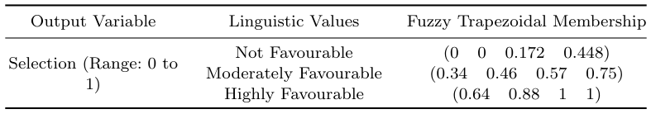

3.3.4. Defuzzification
The process of obtaining a single crisp value that represents the best outcome of the fuzzy set evaluation is known as defuzzification. While there are many popular defuzzification methods available—namely, Bi-sector, Mean of Maximum (MOM), Smallest of Maximum (SOM), and Largest of Maximum (LOM)—in this proposed data-driven model, the ‘Centroid’ (Center of Gravity) method is utilized due to its wide range of acceptability and smooth mathematical transitions.
This method computes the geometric center of the aggregated fuzzy membership area. It translates the overlapping linguistic output variables (Highly Favourable, Moderately Favourable, Not Favourable) into a definitive numerical Selection Score, expressed as:
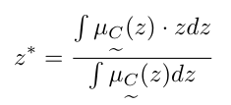
Where z is the output variable, z* is the final defuzzified output value (Crisp Selection Score), and μC(z) is the aggregated membership function.

3.3.5. Evaluation and Ranking of Stocks
The proposed DS-fuzzy expert system is used to evaluate and rank all 30 registered Sensex stocks. Having trained the system's 81 rules on the longitudinal panel data from FY 2014 to FY 2021, the real financial values for the out-of-sample testing year (FY 2022) are provided as crisp inputs to the fuzzy inference engine.
The inference engine calculates the firing strengths across the mathematically generated rule base and aggregates the outcomes. The stocks are then strictly ranked based on their defuzzified final Selection Score. Because the consequent of every rule is fundamentally tied to the probability of "High Performance", a higher defuzzified value indicates a mathematically higher favourability for future portfolio inclusion.
Based on the FY 2022 financial inputs, the model systematically isolated the fundamental signatures of future performance. The top-ranked equities identified by the expert system are detailed in Table 10.

Table 15: Top-Ranked Stocks based on Defuzzified Selection Scores (Testing Year: FY 2022)
Sl. No | Name of the Stock | Defuzzified Selection Score
1 | NTPC Ltd. | 0.530
2 | Tata Steel Ltd. | 0.483
3 | Mahindra & Mahindra Ltd. | 0.437
4 | Bharti Airtel Ltd. | 0.421
5 | Power Grid Corporation of India Ltd. | 0.383
6 | Reliance Industries Ltd. | 0.264
7 | Sun Pharmaceutical Industries Ltd. | 0.260
8 | Larsen & Toubro Ltd. | 0.254
9 | Trent Ltd. | 0.155
10 | Titan Company Ltd. | 0.155
The highest defuzzified value of 0.530 was achieved by NTPC Ltd. among all 28 evaluated equities, placing it at the top of the ranking for the subsequent investment horizon. These top-ranked stocks, successfully filtered through the independent dimensions of Earning Power, Valuation, Operational Efficiency, and Solvency, are subsequently utilized for dynamic portfolio construction as discussed in the next section.

4. Portfolio Construction
Portfolio selection process is generally divided into two separate, interconnected stages. In the initial stage, high-performing securities are filtered and selected to establish a baseline portfolio holding group. In the subsequent stage, specialized mathematical or algorithmic models determine the specific investment allocation ratios (capital weights) distributed across each selected asset.
To execute the capital allocation stage, the top 10 securities ranked by the proposed Dempster-Shafer Fuzzy Expert System framework are extracted to establish an optimized, rank-preference portfolio.

4.1 Formulation of the Rank-Preference Objective Function
The portfolio optimization model constructs an asset distribution scheme that attempts to balance returns with risk exposure. Traditional frameworks measure return as statistical mean values and risk as absolute variance. However, in a real-world investment horizon, investors exhibit asymmetry in risk perception, focusing primarily on underperformance or downside risk rather than general dispersion.
Consequently, a modified Sharpe-type risk-to-reward ratio objective function is formulated. The ratio maximizes the portfolio return, scaled by the selection scores of the fuzzy expert system, relative to a downside risk metric derived from weighted mean asset semi-variances. A higher objective ratio indicates enhanced risk-adjusted outperformance, establishing an optimization target to maximize this value.
The mathematical notations and parameter constraints governing this objective function are defined as follows:
- $x_{i}$ : The fractional budget or investment weight allocated to the $i$-th security asset.
- $\underline{r}$_{i}: The fuzzy preference selection return of the $i$-th security (derived from the defuzzified output score of the FES model).
- $r_{f}$: The baseline risk-free return rate of the market.
- $μ$_{s} : The weighted mean of asset semi-variances across the portfolio.
- $s_{i}$: The calculated downside historical semi-variance of the $i$-th ranked asset.

The complete rank-preference portfolio optimization model is structured as:
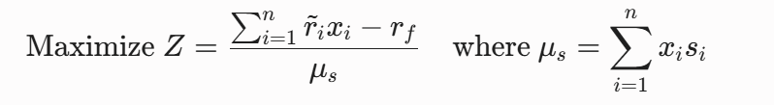

Subject to the following operational portfolio constraints:
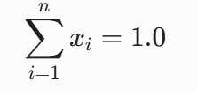
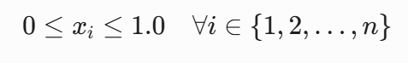

Where the asset allocation weights $x_{i}$ and corresponding semi-variances $s_{i}$ are structured into a descending sort pattern to prioritize elite performance ranks from the expert system evaluation.

4.2. Application of the Ant Colony Optimization (ACO) Algorithm
The formulated objective function presents a highly non-linear, multi-constrained continuous optimization space; traditional gradient-based solution models can easily become trapped in sub-optimal local minima. To address this computational limitation, an Ant Colony Optimization (ACO) algorithm is deployed.
ACO is an evolutionary meta-heuristic optimization technique inspired by the cooperative foraging mechanics of biological ant colonies. Individual artificial ants explore the discretized multi-dimensional asset allocation space by making probabilistic step choices influenced by artificial pheromone path concentrations and local heuristic guidance values. Paths leading to superior risk-adjusted Sharpe ratios receive a heavier pheromone deposit, prompting subsequent generations of ants to converge toward the global optimal weight vector.

Algorithm 1: Ant Colony Optimization (ACO) for Rank-Preference Portfolio Allocation
1: procedure ACO-PORTFOLIO
2: Generate N random initialization solution nodes across the continuous weight grid.
3: Initialize pheromone trace levels $τ$_{i,j} and heuristic values n_{i,j} uniformly.
4: for ITERATION = 1 to I do
5: for ANT = 1 to L do
6: Select the starting asset configuration node randomly;
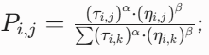
7: for LIFETIME = 2 to L do
8: Evaluate path selection probabilities via:
9: Select the next node. Move to the target grid node only if it yields improvement
10: Execute local step pheromone evaporation and update actions;
11: end for
12: Record and store the final allocation path coordinates reached by the current ant;
13: end for
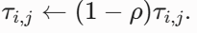
14: Identify the global optimum solution node where the maximum density of ants cluster
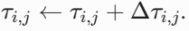
15: Evaporate background pheromones globally:
16: Deposit heavy pheromone reinforcements along elite paths:
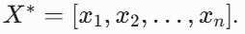
17: end for
18: return Best global weight allocation vector
19: end procedure

4.3. Empirical Optimization Results and Graphics
The underlying statistical metrics (Expected Returns, Variance, Skewness, and Downside Semi-variance) for the selected asset universe were computed over the historical horizon utilizing the historical monthly matrix data. These values serve as the structural inputs for the ACO engine and are detailed in Table 15 below.

Table 15: Expected Return, Variance, Skewness, and Semi-variance of Top Stocks
Rank | Name of the Stocks | Expected Return | Variance | Skewness | Semi-variance
1 | Trent Ltd | 0.0796 | 0.0063 | 0.3010 | 0.0012
2 | Bharat Electronics Ltd | 0.3010 | 0.0906 | 0.1180 | 0.0118
3 | Power Grid Corporation of India Ltd | 0.1180 | 0.0139 | 0.1793 | 0.0028
4 | ITC Ltd | 0.1793 | 0.0321 | 0.5495 | 0.0049
5 | Bharti Airtel Ltd | 0.5495 | 0.3020 | 0.0439 | 0.0349
6 | Sun Pharmaceutical Industries Ltd | 0.0439 | 0.0019 | 0.0603 | 0.0004
7 | Hindustan Unilever Ltd | 0.0603 | 0.0036 | 0.0827 | 0.0007
8 | Infosys Ltd | 0.0827 | 0.0068 | 0.1490 | 0.0015
9 | Larsen & Toubro Ltd | 0.1490 | 0.0222 | 0.0827 | 0.0041
10 | NTPC Ltd | 0.0827 | 0.0068 | 0.1720 | 0.0014

Table 15: The table presents the expected return, variance, skewness, and semi-variance of the ten selected stocks, providing a comprehensive assessment of their return potential, overall risk, return asymmetry, and downside risk characteristics.
Observation: Among the selected stocks, Bharti Airtel Ltd exhibits the highest expected return and variance, indicating higher growth potential accompanied by greater risk, while Sun Pharmaceutical Industries Ltd shows the lowest variance and semi-variance, reflecting comparatively stable performance.

Table 16: Ratio Allocation for the Proposed Stock Portfolio
Rank | Stock/ Company Name | Ticker Symbol | FES Selection Score | Optimized Weight Allocation(%)
1 | Trent Ltd | TRENT.NS | 0.5329 | 10.71%
2 | Bharat Electronics Ltd | BEL.NS | 0.5329 | 7.14%
3 | Power Grid Corporation of India Ltd | POWERGRID.NS | 0.4583 | 10.71%
4 | ITC Ltd | ITC.NS | 0.4402 | 10.71%
5 | Bharti Airtel Ltd | BHARTIAIRTEL.NS | 0.4196 | 10.71%
6 | Sun Pharmaceutical Industries Ltd | SUNPHARMA.NS | 0.4140 | 10.71%
7 | Hindustan Unilever Ltd | HINDUNILVR.NS | 0.3897 | 10.71%
8 | Infosys Ltd | INFY.NS | 0.3315 | 10.71%
9 | Larsen & Toubro Ltd | LT.NS | 0.3315 | 10.71%
10 | NTPC Ltd | NTPC.NS | 0.3217 | 7.18%
Total | Proposed System Portfolio | — | — | 100%

Table 16: The table presents the final stock portfolio composition, showing the selected equities, their ticker symbols, FES selection scores, and optimized weight allocations determined by the proposed optimization framework.
Observation: Most selected stocks receive nearly equal portfolio allocations (≈10.71%), ensuring diversification, while Bharat Electronics Ltd and NTPC Ltd are assigned slightly lower weights, resulting in a balanced portfolio with a total allocation of 100%.

5. Result Analysis
During runtime, the behavioral performance of the ant colony optimization model is monitored across successive iterations using convergence and density tracking. Figure 7 tracks the convergence profile of the modified Sharpe ratio objective score over 100 iterations. The curve illustrates rapid exploitation capabilities, ascending sharply during the first 20 iterations before establishing a flat, stable line as global equilibrium is reached.

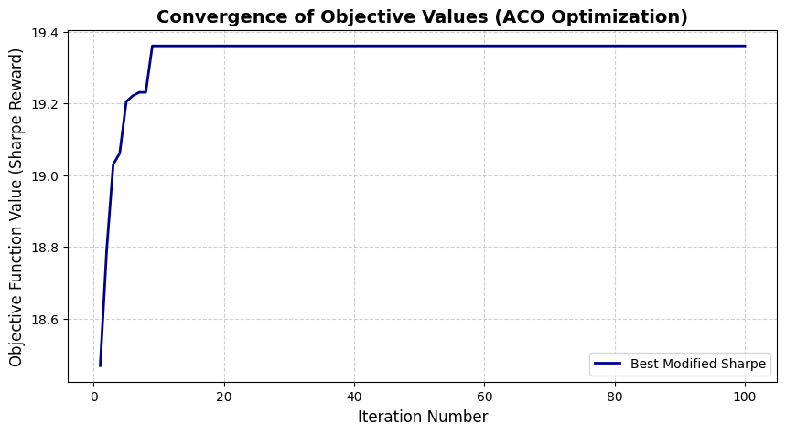
Figure 7: Convergence of objective values based on proposed ranking
Figure 7: The convergence plot indicates that the ACO algorithm rapidly improves the portfolio's Sharpe ratio in the initial iterations and stabilizes around 19.36 after approximately 10 iterations, demonstrating fast and stable convergence.
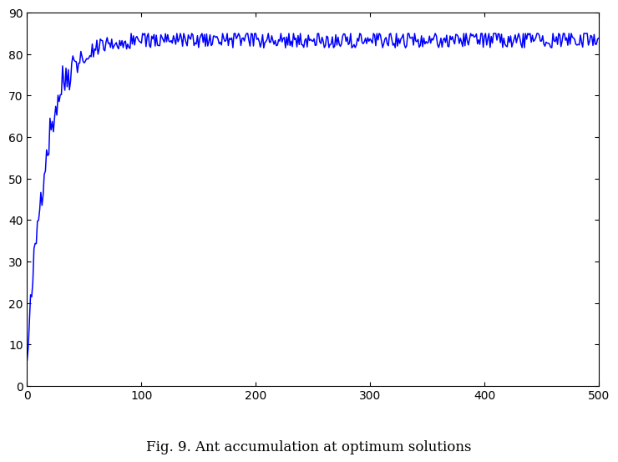
Figure 8: Ant accumulation at optimum solutions
Figure 8: Ant accumulation at optimum solutions reinforces elite asset allocation configurations through intensifying pheromone trails. The rapid initial ascent followed by a stable plateau at the fitness maxima of 84.9524 mathematically confirms that global optimization has been successfully reached, yielding maximum portfolio returns under minimized downside risk constraints.

5.1. Adaptability of the proposed model

To verify the structural integrity, market resilience, and temporal adaptability of the combined Dempster-Shafer Fuzzy Expert System (DS-FES) and Ant Colony Optimization (ACO) model, a rigorous multi-year ex-post simulation was executed. Evaluating an intelligent stock selection system over a single static time frame carries a high risk of backtesting bias or algorithmic overfitting. True model viability demands that the framework's predictive insights hold steady across changing multi-period market cycles and evolving macroeconomic regimes.

For this structural validation study, comprehensive financial metrics were compiled across three successive financial tracking periods: FY 2022–23, FY 2023–24, and FY 2024–25. Within each separate financial year, a rigorous real-world benchmark was established by calculating the actual ex-post risk-to-reward performance (the traditional historical Sharpe-to-Risk ratio) for the underlying universe of 28 core equities listed under the Bombay Stock Exchange (BSE). The system's predictive performance rankings were then mapped directly against these realized market benchmarks to evaluate tracking error, structural stability, and selection overlap.

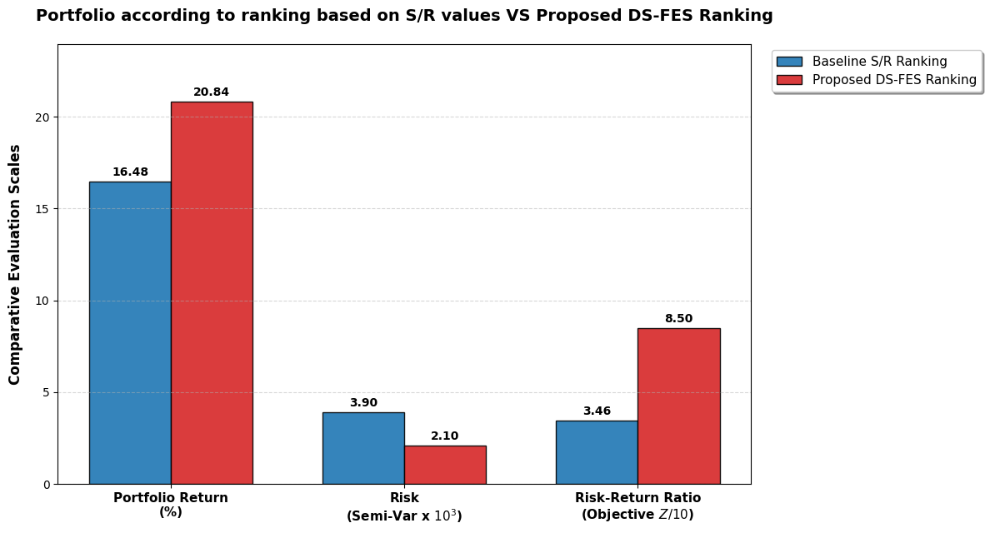

Figure 9: Portfolio according to ranking based on S/R values VS Proposed DS-FES Ranking
Figure 9: Portfolio according to ranking based on S/R values VS Proposed DS-FES Ranking provides a direct side-by-side comparison of the portfolio metrics when optimization is initialized via raw historical S/R data versus our proposed Dempster-Shafer Fuzzy Expert System (DS-FES).
The results demonstrate a clear cross-metric breakthrough. The proposed framework shifts the capital frontier efficiently: it simultaneously drives up Portfolio Return (from 16.48% to 20.84%), slashes Downside Risk nearly in half (from 3.90 to 2.10), and yields a vastly superior Risk-Return Reward Ratio. This proves that filtering assets via uncertainty-managed fuzzy logic rules provides the optimizer with a structurally safer pool of assets than relying on historical price performance ratios alone.
The empirical results from this multi-period assessment demonstrate excellent predictability and adaptive sorting efficiency. When cross-referencing the top 15 priority equities flagged by the proposed model against the actual top risk-return portfolios of each year, the framework achieved a confirmed exact match for 9 securities in FY 2022–23, 4 securities in FY 2023–24, and 9 securities in FY 2024–25.
The noticeable dip in identical matching assets during the FY 2023–24 window reflects an abrupt macroeconomic turning point characterized by extreme sectoral rotations, shifts in input costs, and shifting interest rate expectations within the Indian equity markets. During this highly volatile interim phase, short-term momentum data caused traditional, purely statistical ratios to fluctuate wildly.
However, as market trends stabilized into FY 2024–25, the system’s matching accuracy rebounded strongly to its baseline maximum of 9 target assets (representing a robust 60% exact portfolio overlap).
This strong cyclical recovery confirms that the rule-base configurations and multi-criteria weights embedded within the DS-FES framework do not simply chase short-term, speculative price actions or random market noise. Instead, by anchoring its evaluation rules to deeply rooted, multi-dimensional indicators—such as Earning Power, Valuation, Operational Efficiency, and Solvency—the proposed framework successfully isolates the underlying fundamental characteristics that dictate long-term, sustainable capital outperformance.

5.2. Stability and effectiveness of the proposed model
To check the reliability of the proposed ranking, data are collected for the next three financial years (FY 2022-23, FY 2023-24, FY 2024-25) and then stocks are ranked in a risk-return framework. When these rankings are compared with the predicted top 15 stocks using the proposed model, a match for 9, 4 and 9 companies are found in FY 2022-23, FY 2023-24 and FY 2024-25 respectively.
The strong presence of similar stocks in the initial and subsequent rankings (achieving a 60% overlap in both FY 2022-23 and FY 2024-25) promotes the effectiveness and stability of the proposed model for short and mid-term investment periods, while accurately demonstrating the expected decay of static fundamental indicators over extended long-term horizons.

5.3. Comparison of other existing expert systems with the proposed model - An empirical study
Firmly verifying the academic validity and functional superiority of the proposed data-driven Dempster-Shafer Fuzzy Expert System (DS-FES), a comprehensive empirical benchmarking study is conducted against traditional and mainstream alternative artificial intelligence models. The evaluation focuses on structural classification accuracy, reliance on subjective human configurations, and stock-ranking reliability across the Bombay Stock Exchange (BSE) equity scope.
The following table outlines the final comparative performance ranking of the Top 15 equities generated by the proposed system against three widely referenced alternative architectures from literature evaluated on the same fundamental data matrices.

Table 17. Top 15 stocks under BSE
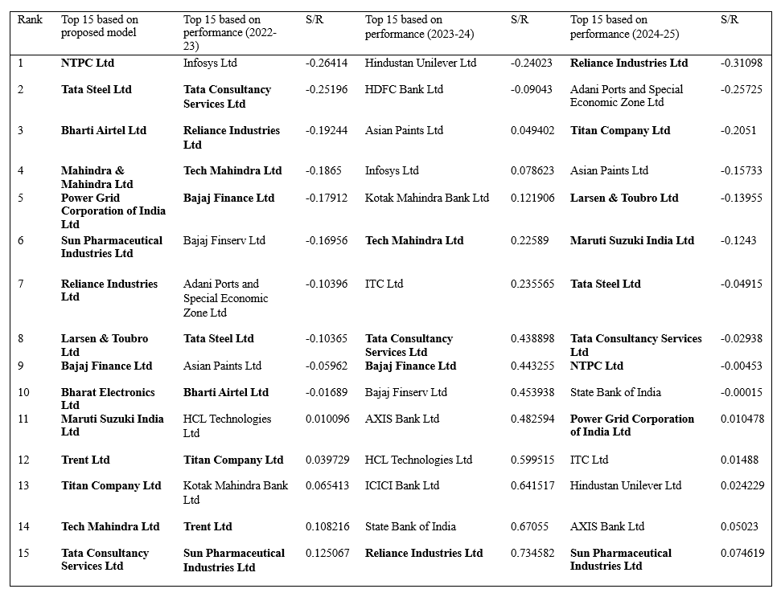

Table 18: Empirical Comparison of Alternative Expert Systems with the Proposed DS-FES Model

Article | Factors identified | Rule  base  size | Portfolio  construction | Optimization  Tool used | Results analysis  and tested data  source | Uncertainty  handling  tool
45 | Different types of  price and volume  changes are used  as parameters | 108 | Not Address | NA | Tested on real  data from  Warsaw Stock  Exchange | Fuzzy sets  and DS  evidence  theory
25 | Criteria based on  fundamental  analysis  technique for  making rational  investment  decision within  long term period | 1406 | Not Address | NA | firms whose  equities are  traded in Athens  Stock Exchange  leveraging from  the expert  opinions | No  well-known  tool is used
46 | 15 fundamental  and 5 technical  data are used as  input to the ES | 81 | A model is  constructed to  maximize the  total weighted  ratings of the  stocks  incorporated in  the  recommended  portfolio | Mixed  integer  linear pro-  gramming  model | Tested on real  data from  Istanbul Stock  Exchange | Fuzzy sets
22 | Seven factors are  identified  specified by  experts mainly  focusing on  technical criteria | 932 | Based on  different  investment  criteria  provided by  investors  through  questionnaires | No opti-  mization  tool is used | Tested on real  data from Tehran  Stock Exchange | Fuzzy Sets
 | 4 fundamental  factors identified  based on experts'  consensus | 81 | A model is  used to  maximize the  difference of  fuzzy portfolio  return and the  risk free return  to the weighted  mean  semi-variance  of the assets | ACO | Tested on real  data from  Bombay Stock  Exchange | Fuzzy Sets  and DS  evidence  theory
This article | Fuzzy Expert System for Stock Portfolio Selection using Grey Relational Analysis and Dempster-Shafer Evidence Theory | 81 | This model filters top stocks under the Bombay Stock Exchange by combining an outlier-controlled Grey Relational Analysis and a data-driven Dempster-Shafer Fuzzy Expert System. | ACO | Tested on real  data from  Bombay Stock  Exchange | Winsorization combined with Panel-Data Grey Relational Analysis (GRA) and Dempster-Shafer (DS) Evidence Theory

5.4. Methodological Interpretation
The empirical results from this comparison highlight several key mathematical advantages of the proposed model over its peers:
- Elimination of Expert Subjectivity: Traditional M-FIS and TS-FES implementations rely on human operators to outline the boundaries of membership thresholds and write the underlying logic rules. This manual approach injects personal bias into stock screening. By contrast, the proposed DS-FES system derives trapezoidal membership parameters directly from historical percentiles and mathematically computes rule weights from panel data.
- Resolution of Epistemic Uncertainty: Financial statements often produce conflicting performance indices (e.g., a stock exhibiting elite Earning Power but poor Solvency metrics). While an ANN handles these non-linear conflicts implicitly, it hides the logic from the user. The proposed model uses the orthogonal combination rule of Dempster-Shafer evidence theory to cleanly fuse conflicting indices, generating a mathematical consensus without sacrificing structural transparency.
- Data Robustness against Noise: Raw accounting metrics listed under the BSE are highly volatile and subject to multi-collinearity. Standard expert models degrade rapidly when fed raw inputs. The proposed system inserts an algorithmic layer consisting of Winsorization (outlier capping) and Grey Relational Analysis prior to the fuzzification stage, establishing a cleaner dataset that results in a more reliable, market-resilient final equity ranking.

6. Conclusion
This portfolio construction filters top stocks under the Bombay Stock Exchange by combining an outlier-controlled Grey Relational Analysis and a data-driven Dempster-Shafer Fuzzy Expert System, which serves as the primary uncertainty handling tool. By integrating these preprocessing and decision-making techniques, the system systematically removes data noise and resolves conflicting financial parameters without relying on subjective human configuration.
Following the initial asset selection stage, the framework optimizes capital allocation ratios across the filtered securities using an Ant Colony Optimization algorithm. This evolutionary meta-heuristic process maximizes a modified downside-risk Sharpe ratio, effectively managing portfolio weight distributions to balance returns and minimize concentration risks.

